Assignment 1
Darron Singh | 100584624
Jasindan Rasalingam | 100584595
Ashwin Kamalakannan | 100584423

Link to repository here

Pseudo Algorithm
For our algorithm to work, we read the input and write the data to a list of order pairs. This is our vertex list. We then iterate through all possible combinations of lines using this vertex list. For each line constructed, we run an extend line algorithm on it. The extend line algorithm checks for intersection with other lines and either extends the line to meet the new length. If a new length is achieved, we recursively call our extendline algorithm again to check for new possible intersections. Finally, we return the points A and B from the function of the maximum possible line.

vertices = readfile() # n

maxLine(vertices) function:
x1, y1 = [0, 0]
x2, y2 = [0, 0]
max = 0
for i in list of vertices # n
for j in list of vertices # n-1
if i = j, skip this iteration
i, j = extendLine(vertices, i, j) # O(n²)
tmax = getDistance(i, j)
if tmax > maxDistance
x1, y1 = i
x2, y2 = j
max = tmax

print x1, y1
print x2, y2
print max
return [x1, y1], [x2, y2]

extendLine(vertices, i, j) function:
for a in list of vertices # n
if a is last element
b = first
else
b = a + 1

poix, poiy = getIntersection([i, j], [a, b])

if lines are parallel, skip iteration

if intersection within i and j
if intersection is endpoint a or b
continue
else
break

else if intersection outside of i, j but inside a, b
replace i and j with poix and poiy
recursively call extendLine(vertices, v1, v2) # n-1

else, skip if intersection occurs outside bounds of polygon

return i, j

Runtime Analysis
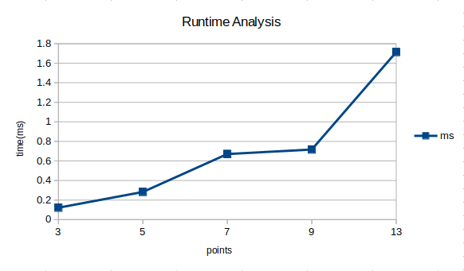
We used Python 2.7 on a Dell Precision 3520 with an Intel(R) Core(TM) i5-7300HQ CPU @ 2.50GHz with 8GB RAM running ubuntu 17.04.
Our algorithm uses a brute force approach, and as a result the worst case scenario is an O(n⁴) time complexity. This poor runtime is a result of us nesting multiple for loops within each other. However, according to our testing the average runtime for our algorithm doesn’t show a steep increase in runtime. This could be due to the individual test cases not needing as many nested loops or recursive calls. We figured that for convex polygons, our runtime will be closer to O(n²) because there won’t be any line extending. Concave polygons Give us more trouble because there are cases where we can have corner to edge intersection, and intersections with corners within the polygon itself which need to be ignored. In order to make our algorithm faster, we need to optimize our logic for generating lines.

Test Cases
3 vertices
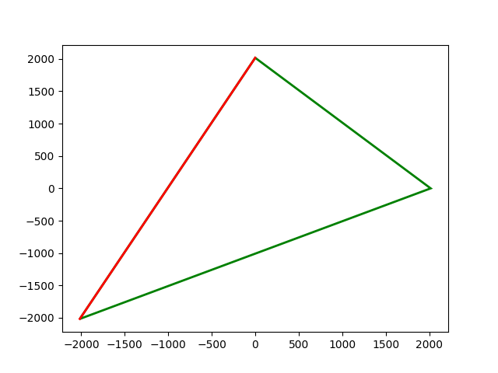
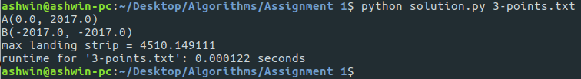

5 vertices
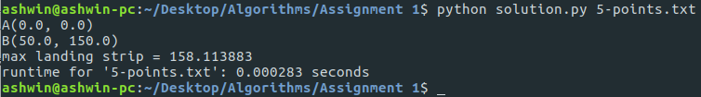
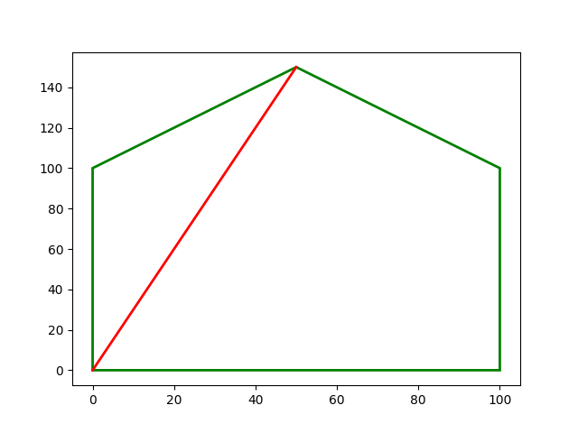

7 Vertices
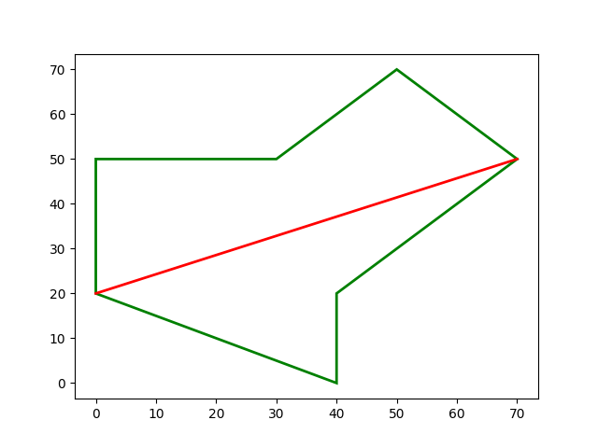
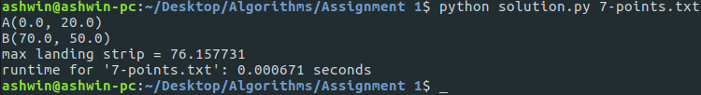

9 vertices
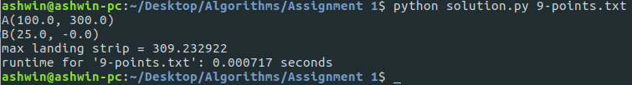
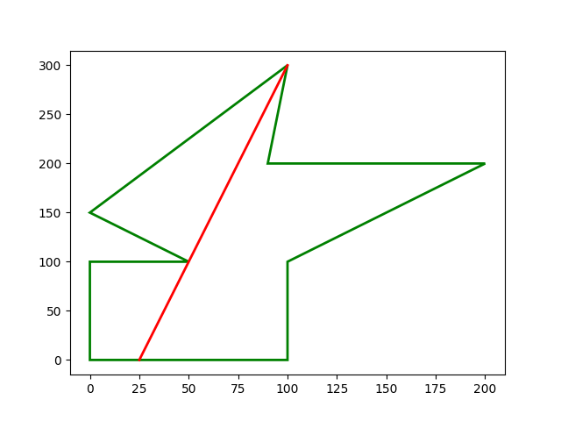

13 vertices
